This Belongs to…
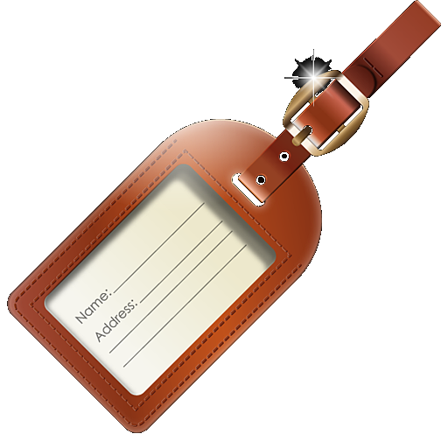
Lock ‘em down!
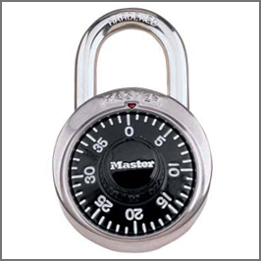

Online Information is like toothpaste because…
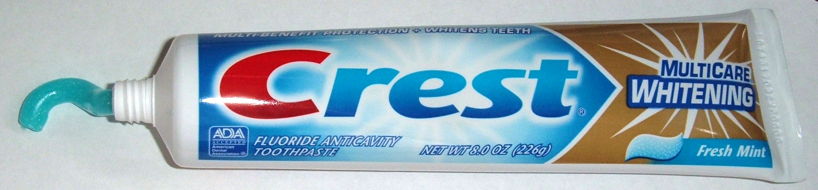

Posts are Permanent.

Sharing is NOT Caring!
